Banana Cake
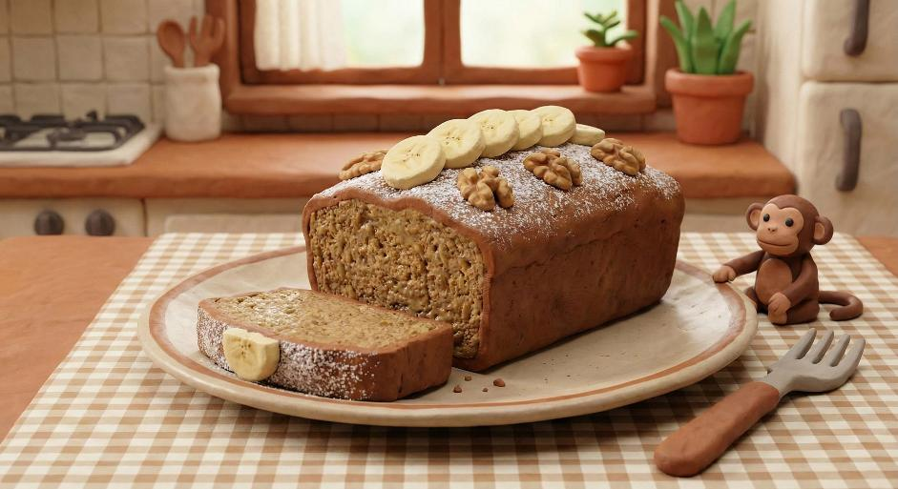
Ingredients
3 very ripe bananas, mashed
100 g butter (melted) or neutral oil
150 g light brown sugar
2 eggs
1 tsp vanilla extract
200 g plain flour
1 tsp baking powder
1/2 tsp bicarbonate of soda
1/2 tsp ground cinnamon (optional)
Pinch of salt
2 tbsp milk (only if the batter feels very thick)
Method
Heat the oven to 180°C (160°C fan). Grease and line a 20 cm round tin (or a 2 lb loaf tin).
In a large bowl, mash the bananas until mostly smooth.
Stir in the melted butter/oil and sugar until combined.
Beat in the eggs and vanilla.
In a separate bowl, mix the flour, baking powder, bicarbonate of soda, cinnamon (if using) and salt.
Fold the dry ingredients into the wet mixture until just combined (don’t overmix). Add milk if needed.
Pour into the tin and level the top.
Bake for 35–45 minutes (round tin) or 45–55 minutes (loaf), until a skewer comes out clean.
Cool in the tin for 10 minutes, then turn out onto a rack to cool fully.
Optional extras
Add 100 g chocolate chips or 80 g chopped walnuts to the batter.
For a quick topping, dust with icing sugar or spread with cream cheese frosting once cool.

